SOFTWARE REQUIRMENT

SPECIFICATION



H.O.B.B.I.T

*‘OUTGROW YOUR INTEREST*’

TEAM MEMBERS

1. ARUSHI SEHGAL (BT17GCS017)-C1
2. ARUNDHATI DAS (BT17GCS016)-C2
3. AYUSHI KAPOOR (BT17GCS020)-C2
4. ANJALI MISHRA (BT17GCS154)-C2
5. TANISHA GARG (BT17GCS113)-C1
6. BHAVYA MASUPALLI (BT17GCS271)-c1
7. HIMANSHU NIKHARE (BT17GCS036)-C4

**TABLE OF CONTENTS**

1. Introduction....................................................................................................................4

1.1   Purpose.......................................................................................................................5

1.2   Scope…………….………….................................................................................... 5

1.3   Intended Audience.....................................................................................................5

1.4   Definitions, Acronyms & Abbreviations...................................................................5

1.5 Advantages……...…………………………………………………………………....5

1.6 References....................................................................................................................5

2.   Overall Description......................................................................................................5

2.1   Product Perspective....................................................................................................5

2.2   Product Functions.......................................................................................................6

2.3   User Characteristics…………....................................................................................6

2.4  Constraints.................................................................................................................. 6

3.  Interface Requirement..............................................................................................….7

4.   Hardware Interface...................................................................................................... 8

5.   Software Interface....................................................................................................... 8

6.  Communication Interfaces............................................................................................8

7. Specific Requirements...................................................................................................9

7.1  Functional Requirements............................................................................................9

F.R.1  Create Account Description....................................................................................9

F.R.2   Sign In Account Description..................................................................................10

F.R.3   Choosing Group Description…………................................................................. 10

F.R.4 Searching Group Description……………………………………………………...11

F.R.5  Creating Group Description…………................................................................... 12

F.R.6   Uploading  Photos Description…………............................................................. 13

F.R.7   Creating Albums Description…………............................................................... 13

F.R.8   Sharing Status Description…………....................................................................14

F.R.9   Commenting ………….........................................................................................15

F.R.10  Create New Page Description…………............................................................. 16

F.R.11  Sending Message Description…………............................................................. 16

F.R.12  Send Attachment Description..…………………...……...……………............... 17

F.R.13  Uploading Video Description................................................................................17

F.R.14  Notes Description…………..................................................................................17

F.R.15  Videos Description................................................................................................17

F.R.16   Notification Description………….......................................................................18

F.R.17   Update Profile Description…………...................................................................18

F.R.18  Create an Event Description……………………………………………….…....19

F.R.19 Privacy Setting Description………………………………………………………19

F.R.20 Discussion Forum Description……………………………………………....…....19

F.R.21 Nearby Event Description…………………………………………………..…….20

7.2.  Non Functional Requirements…………………………………………………........21

8. Gantt Chart………………………………………………………………...…………..23

**1.INTRODUCTION**

This document is prepared in order to determine a software requirement specification for the  app H.O.B.B.I.T . This is a social network platform on which people can join different clubs of their interest, share videos and photos ,send and receive messages , comment and like on the posts,attend events  etc. on the basis of their interests . In addition to these advanced system features that are described elaborately there are more interactive features which also make use of the app easier for non - techno savvy users.

**1.1 PURPOSE**

The SRS is REQUIRED to evolve as the development of the software product processes. The main aim of this document is to provide us with a complete description about how H.O.B.B.I.T , the social network system app  can be developed. This document is made to provide information about what the software product is and what its functionalities are to do with client interface and establish an agreement between people with similar interests. To protect user privacy, this app has controls that allow users to choose who can view their profile, contact them, add them to their list of contacts and so on.

**1.2 SCOPE**

The name of the software product is H.O.B.B.I.T.It is a social networking site  that connects people via a digital platform. The aim of our app is to provide information to the users about the events and the people whom they apprehend. The users of H.O.B.B.I.T can add friends, share videos, upload photos, comment on the posts, chat and stay updated. Moreover, people can create social groups for such as university clubs, football clubs or for social awareness. People can be informed about the events by the help of these groups or their friends using a calendar.

**1.3 INTENDED AUDIENCE**

This document is meant for a varied set of audiences. This document serves as a contract agreement with developer. The document is intended for the software developer authorities, the design team, developers, project manager, team leads, supervisors, security analysts, testing team and the QA team to better understand the system necessities , Knowledge and understanding of UML diagrams is also needed.

**1.4 DEFINITIONS, ACRONYMS AND ABBREVIATIONS**

When the user logins into the app, they’ll see their home page, which is called as “News Feed” that offers users to envision what their friends have shared in the form of stories and posts . Moreover, the user will see the event invites and calendar updates. Therefore, News Feed is that main page which combines daily friend interactions.

**1.5 ADVANTAGES**

The advantages of this app is to bring people of similar interests closer.Usually , users of a particular  geographical location may be interested in similar activities and hobbies but are unable to connect due to various factors . Therefore, to make the people of varied interests come closer, this app helps to join in and make the world a happier and closer place . Moreover, this kind of app helps people who have recently located to find and make new friends.

**1.6 REFERENCES**

     IEEE SRS Format.

     TGMC-2008 Sample Synopsis Format.

**2. OVERALL DESCRIPTION**

In this section, background information about what sort of requirements the system ought to have will be provided briefly.

**2.1 PRODUCT PERSPECTIVE**

Hobbit is an independent and university centric social network app. Every person can use it online. The Hobbit is not a part of a larger system. People having varied interests can connect to it and exchange information with other people. In order to control the contents of the sharing and comments done by other people, Hobbit has also a control mechanism. People can deliver their complaints about any part of the Hobbit to the “Hobbit Administrators”. Then, “Hobbit Administrators” might take appropriate actions according to the complained situation which is against the rules.

**2.2 PRODUCT FUNCTIONS**

Hobbit is an independent and university centric social network app. Every person can use it online. The Hobbit is not a part of a larger system. People having varied interests can connect to it and exchange information with other people. In order to control the contents of the sharing and comments done by other people, Hobbit has also a control mechanism. People can deliver their complaints about any part of the Hobbit to the “Hobbit Administrators”. Then, “Hobbit Administrators” might take appropriate actions according to the complained situation which is against the rules.

**2.3 USER CHARACTERISTICS**

Hobbit doesn’t need any specific computer knowledge to use except at the developers end. Users can be from 18 - 80 years of age from any gender or specialization of education in the university. On the other hand, administrators and potential developers requires a high level of expertise to understand web technologies.

**2.4 CONSTRAINTS**

Being a social network app, the software ought to ensure the safety of information given by the user and provide some privacy settings options to prioritise  and manage the user data and in addition limits its scope. Firstly, Hobbit provides individuals the right to choose the category of people who will be able to view their shared items. Some users might not want the access of some individuals to their shared items and information. If this is the case, users can set their privacy settings to prevent some people’s access to their information. Secondly,the unwanted users can also be restricted to access of the information by

enabling the block feature. Third, Hobbit cannot sell the data bits of the users to organizations or persons outside the university.

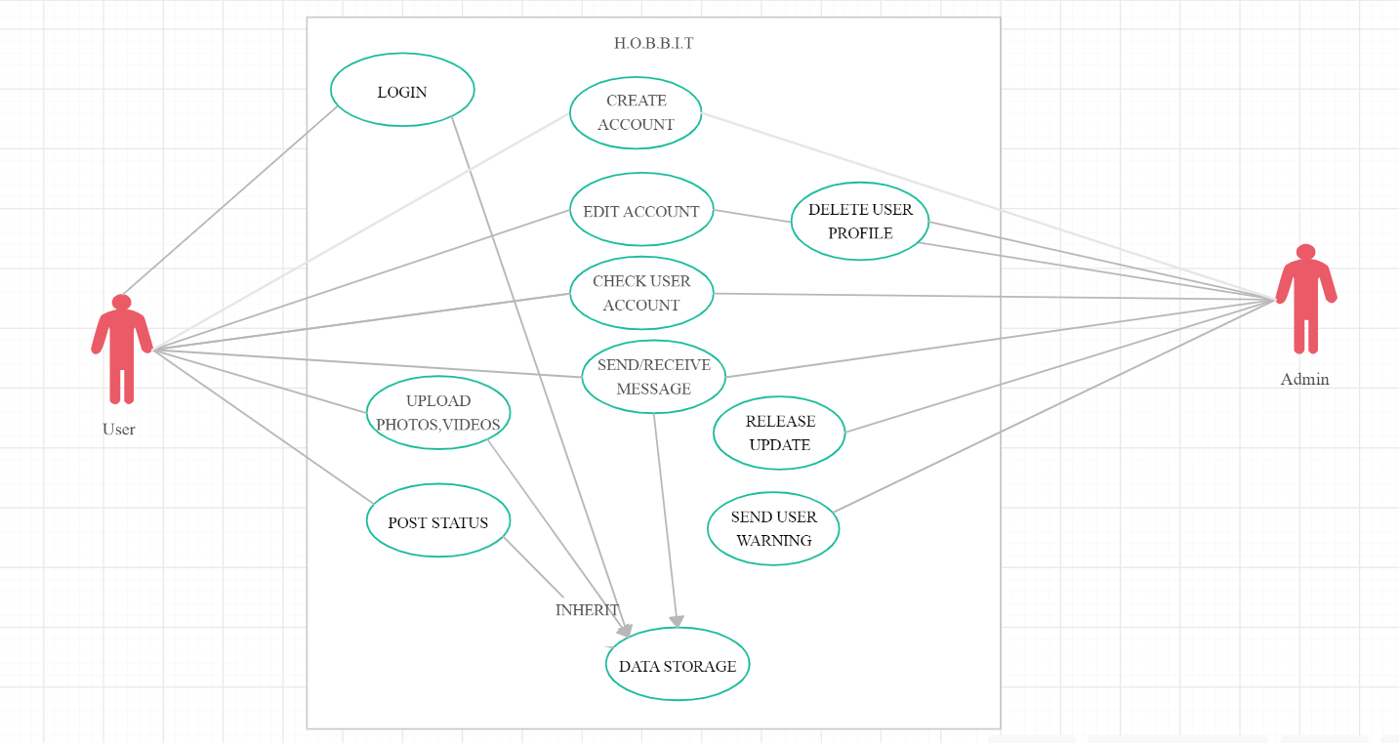

**Figure :** Use Case Diagram for H.O.B.B.I.T App

**3. INTERFACE REQUIREMENT**

Various interfaces for the Hobbit could be

1. Login Page

2. Home Page

3. There will be a screen displaying news feeds, join group,Discussion Forums, suggestion,etc.

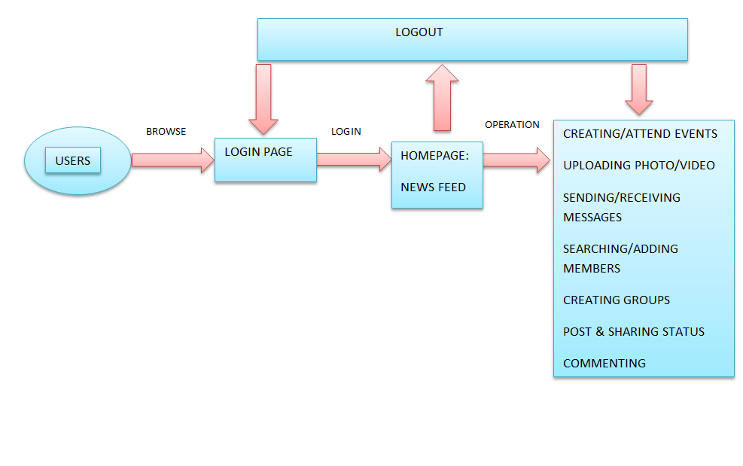**Figure:**Diagram for Standard User Interface For H.O.B.B.I.T App

**4. HARDWARE INTERFACE**

A smart phone with internet connection ability is the hardware interface of this system. Internet connection of smart phone is also required. A working based smart phone with version 2.2 or above and internet connection are necessary.

**5. SOFTWARE INTERFACE**

The system is on server so it requires any scripting language like PHP, VBScript etc. The system requires database also for the store any transaction of the system like MYSQL etc. system also require DNS (domain name space) for the naming on the internet. At the last user need web browser for interact with the system.

**6. COMMUNICATION INTERFACES**

The network communication is always necessary for the application to run. Since all the information, i.e. user information, album information, messages, etc. of the system is kept in a server and all the processing is done on the server side, hence network communication is vital for Hobbit app.

**7. SPECIFIC REQUIREMENTS**

In this section, all software requirements will be explained  in detail. All requirements are divided into two groups as functional and non- functional.

**7.1 FUNCTIONAL REQUIREMENTS**

A functional requirement defines a function of a system or its component.

**F.R. 1 – Create Account DESCRIPTION**

 If user is new and does not have an account on H.O.B.B.I.T.

* INPUT-Request for first name, last name, email id/phone no. and password.
* PROCESSING-Retrieves the provided information and makes a new account for user.
* OUTPUT- Displays created account.

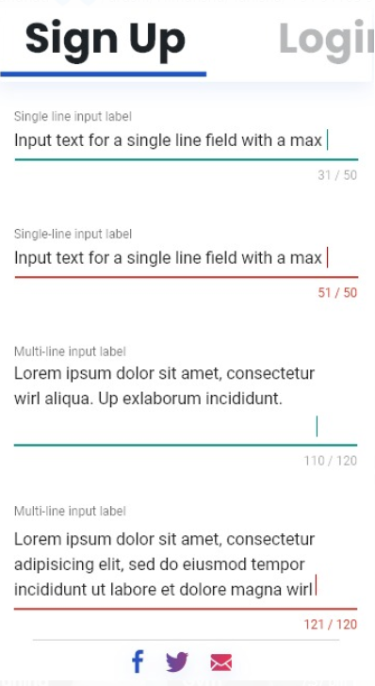

**F.R. 2 – Sign in Account DESCRIPTION**

If user already have an account on H.O.B.B.I.T.

* INPUT-email id/phone no. and password.
* PROCESSING-Retrieves the provided information.
* OUTPUT- Displays News Feed.

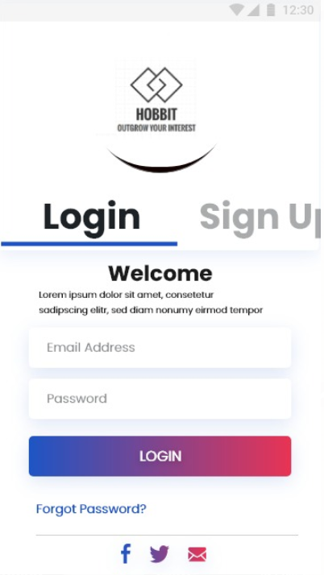

**F.R. 3 – Choosing  groups DESCRIPTION**

User chooses the Interest Group.

* INPUT- choose group page will be Displayed.
* PROCESSING- User will choose interest groups of their choice from already existing group list of groups.
* OUTPUT- Name of  Group displayed selected by the User.

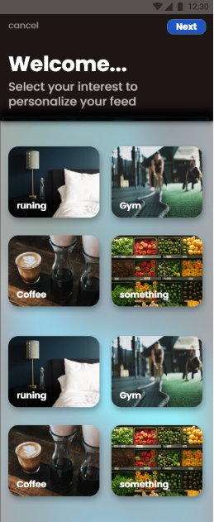

**F.R.4 – Searching groups DESCRIPTION-**

User searches for Interest Group to join.

* INPUT- Click on search,enter name of Interest Group.
* PROCESSING- User clicks on search , enters name and then list of groups are displayed of that name.
* OUTPUT- Name of  Group displayed.

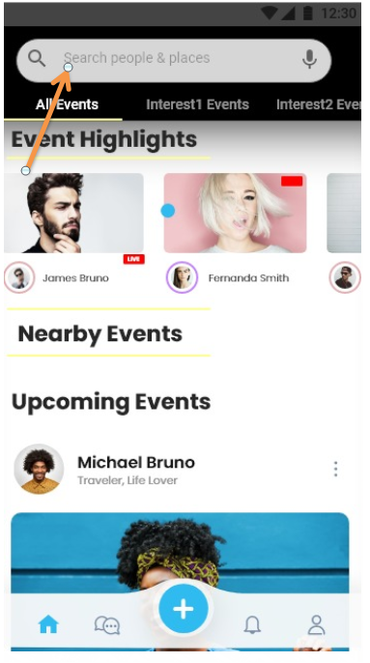

**F.R.5 – Creating Groups DESCRIPTION-**

 One can create groups on Hobbit.

* INPUT- Click ‘profile’ at the top, click ‘groups’ ,click ‘see all’, tap ‘create group’,name group, add some people,add description , select privacy and click ‘save’.
* PROCESSING- When someone click on ‘groups’ transferred to ‘see all’ and adds the name,people,description and selects privacy transferred to ‘save’.
* OUTPUT-Group created.

**F.R.6 – Uploading Photos DESCRIPTION**

Users can add photos on Hobbit to update their activities.

* INPUT- Tap ‘photo’,select photo to upload ,tap ‘done’.
* PROCESSING- User clicks on ‘photo’, transferred to ‘select’, photo selected by user then transferred to tap ‘done’.
* OUTPUT-Photo uploaded successfully.

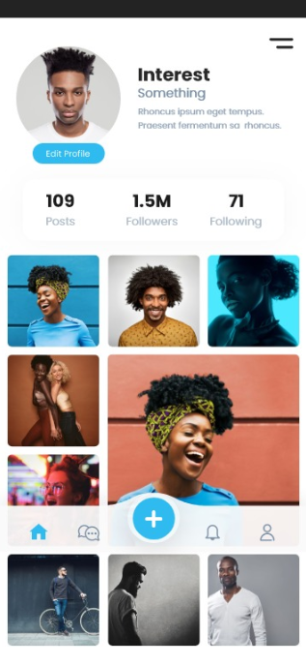

**F.R.7– Creating Albums DESCRIPTION**

User can add Hobbit photos and create album

* INPUT-Go to ‘update status’, create ‘photo album’, choose order of photos, choose album cover, choose privacy and post.
* PROCESSING- OUTPUT-Album Created.

**F.R.8 – Sharing Status DESCRIPTION**

When someone clicks Share below a post, they are able to share your photos, videos or status updates through Hobbit.

* INPUT-Search post to share, tap ‘share’ , tap ‘write post’ and tap ‘share now’.
* PROCESSING- User clicks on share , transferred to write post and then clicks on ‘share now’ to share.
* OUTPUT- Post shared by the user.

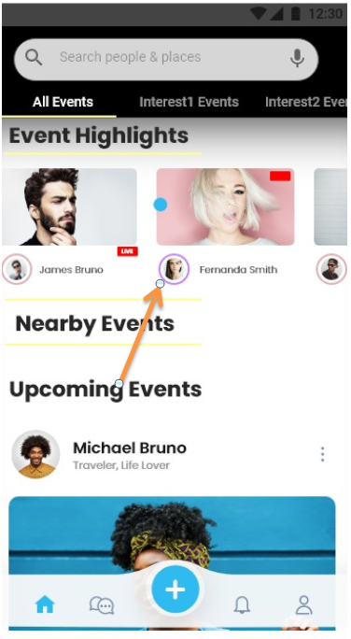

**F.R.9 Commenting**

This feature will allow individuals to comment on shared status on hobbit. This           would be done by an interface of text field located at the bottom of every status.

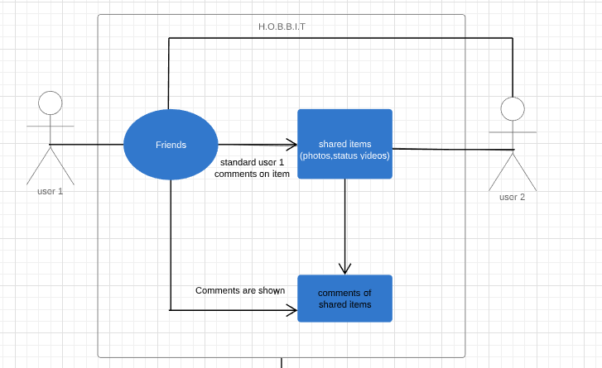

**Figure:**Diagram for commenting

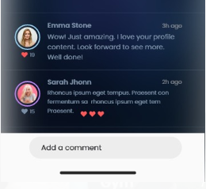

**F.R.10  – Create New Page DESCRIPTION**

One can create a new page on to add his/her activities.

* INPUT- Tap on ‘pages’,tap ‘create page’,tap ‘get started’, select name, select categories ,add cover photo,profile picture for page,tap ‘visit page’.
* PROCESSING- User tap on ‘pages’ ,transferred to ‘create page’ and then clicks ‘get started’ ,transferred to add name ,cover photo ,profile photo and then tap on ‘visit page’ to see the created page.
* OUTPUT- A new page created.

**F.R. 11– Sending Message DESCRIPTION**

A user should be able to send instant messages to the members of the interest group. User should be notified when messages are successfully delivered to recipient by displaying a tick sign next to message sent.

* INPUT- Message typed.
* PROCESSING- Message send to other user.
* OUTPUT- Tick on Message.

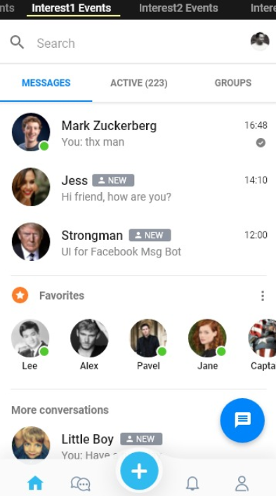

**F.R. 12– Send Attachments DESCRIPTION-** A user should be able to send audio, video and images as attachments.

* INPUT- File attached.
* PROCESSING-Send to other side user.
* OUTPUT-Tick on file.

**F.R. 13 – Uploading Videos DESCRIPTION-** User can upload video in his/her account.

* INPUT- Click ‘add video’ button, choose file, add description and post.
* PROCESSING- User clicks on ‘add video’, transferred to choose files and then clicks on ‘post’ to upload and then video uploaded.
* OUTPUT-Video uploaded successfully.

**F.R. 14– Notes DESCRIPTION-**

User can add notes.

* INPUT- Select ‘more’ at right of profile picture, click ‘notes’, click ‘add notes’ , drag file, create note and ‘publish’.
* PROCESSING- User clicks on ‘more’, choose notes and clicks to add, and then attaches file then click to create and ‘publish’.
* OUTPUT- Note published.

**F.R.15– Videos DESCRIPTION-**

 User can watch uploaded videos on Hobbit.

* INPUT-Search videos, click to watch.
* PROCESSING- User searches for a video in ‘search’ and a list of videos related to search displayed and then click to watch.
* OUTPUT- Video is watched by the user.

**F.R. 16– Notifications DESCRIPTION-**

Notifications are updates about activity on Hobbit.

* INPUT-Tap the globe icon, click see all.
* PROCESSING- user click on globe icon then list of notifications displayed.
* OUTPUT-List of notifications displayed.

**F.R. 17 – Update Profile DESCRIPTION**

User can update his profile picture, can add birthday, and can add their bio, nickname from function ‘update profile’.

* INPUT- Asks to update user’s profile picture, cover picture, education, etc.
* PROCESSING- Stores the information and processes the request.
* OUTPUT- Updates profile as provided by user.

**F.R. 18– Creating an Event DESCRIPTION-**

User can create an Event through his Page to connect to his audience.

* INPUT- Click on ‘create event’ tab, choose name, add location and time.
* PROCESSING- store the information and process the request.
* OUTPUT-Event created in the calendar section of the app.

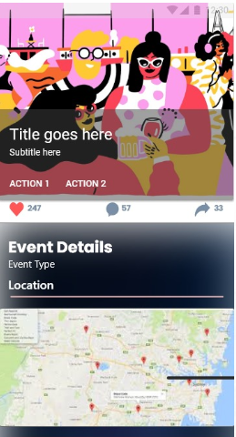

**F.R. 19- Privacy Setting DESCRIPTION-**

The user can manage privacy setting so that can effectively manage their profile. .

* INPUT- Asks to establish an authorization as to who can view profile .
* PROCESSING- The information is stored and  the request is processed . The changes are then applied  to change users account properties.
* OUTPUT- Applied changes are reflected on the users account.

**F.R. 20 – Discussion Forum DESCRIPTION**

A user should be able to Discuss with all other members of the Interest Group.

* INPUT- Message typed.
* PROCESSING- Message send to all other users.
* OUTPUT- Tick on Message .

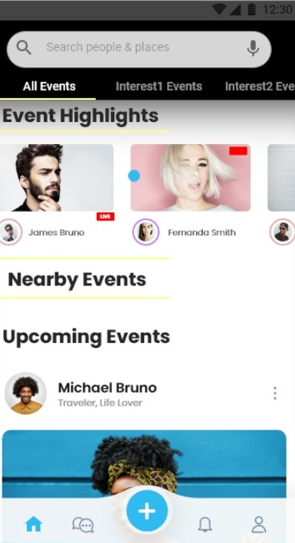

**F.R. 21 – Nearby Events Description**

To see the location of the nearby events as per your description

* INPUT-  Users location.
* PROCESSING- Shows the location of nearby events according to users preference.
* OUTPUT- Shows the ongoing events.

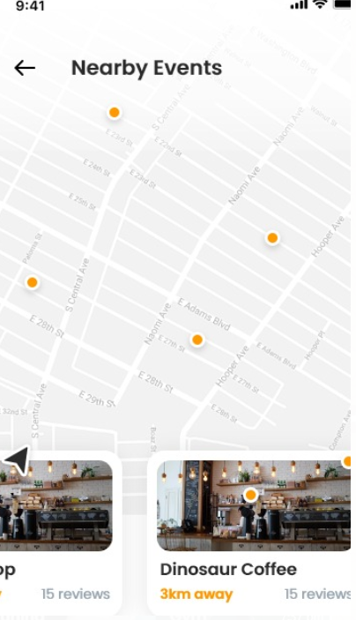

**7.2 NON-FUNCTIONAL REQUIREMENTS**

1. **Security**- The system use SSL (secured socket layer) in all transactions that include any other confidential passenger information. The system must automatically log out in all customers after a period of inactivity. The system should not leave any cookies on the customer's computer containing the user's password, system's back-end servers shall only be accessible to authenticated administrators. Sensitive data will be encrypted before being sent over insecure connections like the internet.
2. **Reliability-** The system provides storage of all databases on redundant computers with automatic switch over. The reliability of the overall program depends on the reliability of the separate components. The main pillar of reliability of the system is the backup of the database which is continuously maintained and updated to reflect the most recent changes. Thus the overall stability of the system depends on the stability of container and its underlying operating system.
3. **Availability-** The system should be available at all times, meaning the user can access it using a web browser, only restricted by the down time of the server on which the system runs. In case of a hardware failure or database corruption, a replacement page will be shown. Also in case of a hardware failure or database corruption, backups of the database should be retrieved from the server and saved by the administrator. Then the service will be restarted. It means 24 X 7 availability.
4. **Maintainability-**A commercial database is used for maintaining the database and the application server takes care of the site. In case of a failure, a re-initialization of the program will be done. Also the software design is being done with modularity in mind so that its maintainability can be done efficiently.
5. **Portability-** The application is HTML and scripting language based so that end user part is fully portable and any system using any web browser should be able to use the features of the system, including any hardware platform that is available or will be available in the future. An end-user  uses this system on any OS; either it is Windows or Linux. The system shall run on PC, Laptops, and PDA etc.
6. **Safety Requirements-**The application must ensure that it leaves untouched the input image files. No modification is allowed to these files. Moreover, the application should function even in cases of wrong data insertion or wrong settings. In case of erroneous situation in any page the application should provide users with appropriate help messages.
7. **Business Rules-**Everyone from the university can use this app and connect with like-minded people having similar interests.Some of the interests groups included in our app.

They are:

* Cycling
* Writing
* Walk & Talk
* Astrology
* Poetry
* Gaming
* Exploring nature
* Binge Watching
* Vlogging
* Coding
* Social service
* Sports

**8.GANTT CHART**

